Energy Efficiency Coin – Draft White Paper
Working draft for discussion. Not final. Open to changes once a group forms.

1.0 The Problem
Proof-of-work mining uses a lot of electricity. Power is usually the biggest ongoing cost. When rates go up or the hardware is inefficient, margins get thin or go negative. Miners chase the cheapest power they can find, and there is little direct push to upgrade machines or improve how energy is used. There is no built-in reward just for running more efficient hardware.
Energy Efficiency Coin is an attempt to add that missing piece. It is a separate token paid when a miner hits a clear efficiency number, measured in joules per hash. Bitcoin is the example I keep using because everyone knows it, but the idea is not limited to Bitcoin. It should work for other mineable coins too. The point is to give the person running the hardware a reason to look for better ASICs, better software, and better energy setups without touching the coin they are actually mining.

2.0 How It Would Work
Efficiency is simple math: wall power in watts divided by hashrate. I have been using 12 J/TH as a working number for discussion, roughly in the range of current 1373-class chips. If the setup is at or under that number, it qualifies.
For a home miner the measurement can be a plug-in meter like a Shelly on the wall. Bigger farms would use rack meters or PDUs. Same idea either way. A small separate machine (a spare node or Pi) collects the power data and the hashrate, watches for a block, and packages everything together. For the first version I am only looking at solo mining. When that solo miner finds a block and the rig meets the efficiency bar, the package gets built and sent.
The package includes the block info, the efficiency reading, and some way to identify the hardware (MAC address or similar for now). It does not go inside the Bitcoin block. It goes to a validator and then to Solana, where the token is minted. Multiple miners can share one wallet; only the ones that actually meet the number get counted.
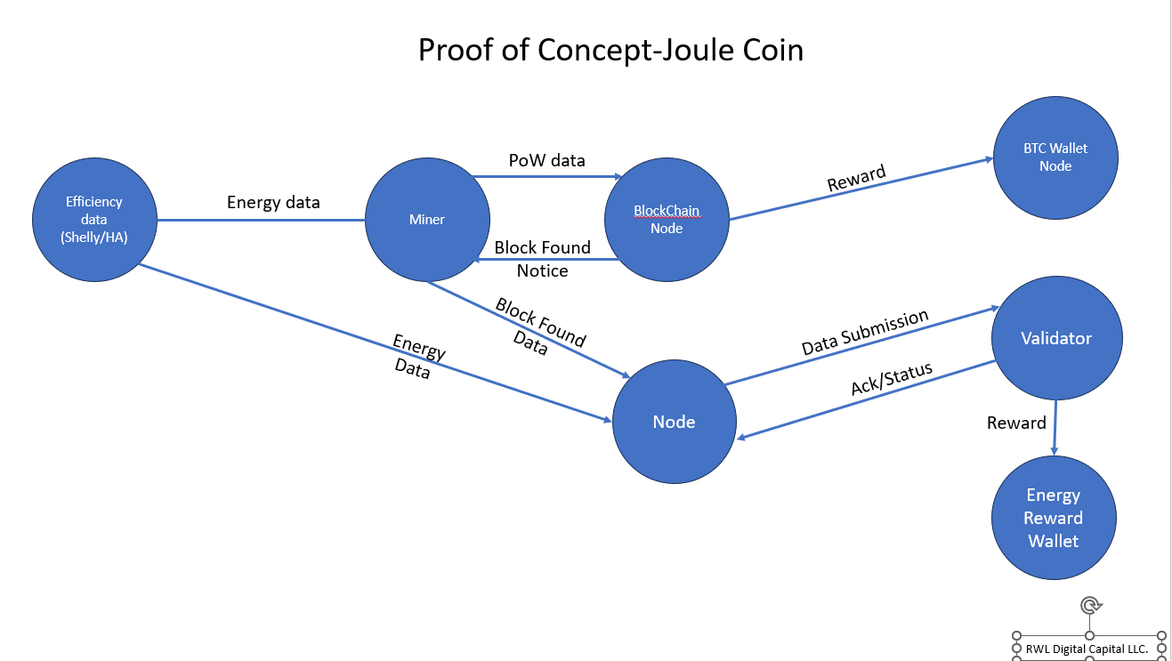
Figure 1. Proof of Concept flow (Joule Coin).

3.0 Connectivity and Processing
Home and remote sites lose internet sometimes. The collector should queue the proof packages locally and send them when the connection comes back. On the receiving side the validator can batch them up. Every ten minutes is a reasonable starting point because these claims are not time-sensitive. Solana handles the actual blocks and transaction limits; the batches just need to fit inside what it allows.

4.0 Token Basics
The token is minted only when a qualifying event happens. It is not on a fixed schedule. Supply grows with real efficient blocks (or whatever the final rule becomes). I have talked about keeping it uncapped at first, with the option to add a limit later if volume gets high. Rising energy prices make efficient hardware more valuable to the miner anyway; the token is an extra push on top of that.
Founder or early contributor rewards should exist because people do not work for free. One simple version I have looked at is a small seed amount up front, then 1% of each future mint, with a one-year vest so there is a reason to stay involved. If the founder is no longer around, that slice can be burned or sent to a foundation if one is set up. Large day-one pre-mines have caused problems for other projects, so the preference is to keep any allocation modest and tied to actual activity.
The token needs some real use or it will not hold value. The most straightforward use is as a matching claim someone can hold or retire next to their mined coins. Selling it for SOL or USDC is the obvious cash-out path for miners. Other ideas (energy companies accepting it, broader payments) would require liquidity and demand that do not exist yet.

5.0 Getting It Out and Keeping It Going
The collector software can start as something an individual downloads and runs. Longer term it could be a plugin that firmware projects or manufacturers add if they want. Liquidity would begin on a Solana DEX. Real exchange listings and deeper markets are harder and later. A non-profit or visible backer who wants the public story is one way to fund the early work and seed a pool.
Testing can be done in a closed loop on Solana devnet with free test SOL and a test token. No real money required to prove the packaging and mint path.

6.0 Open Items
The exact efficiency number, how strictly measurement is verified, whether and how to expand beyond solo mining, final token supply rules, founder allocation details, and what actual demand looks like are all still open. This paper is a draft to capture the current thinking so a group can refine it.
End of draft.

